**Bachelor Thesis Progress Report Part 1**

Savva Krasnokutskii

Table of contents

A.Fundamental concept

B.Research conducted

C.Project’s technical characteristics

A.Fundamental concept

The fundamental goal of machine learning, the Philosopher’s stone of this discipline, lies in the creation of a self improving model, capable of single handedly, without human intervention constructing better versions of itself. So far no such model exists (at least it is not publicly available).

My hypothesis is that the creation of such a model could be made possible, by shifting the approach we use, via changing the paradigm, where instead of teaching the model, be so directly or indirectly we shift our focus from model oriented approaches, to the environment oriented ones.

Let us look at the existing example, humans. Humans are an intelligent species, capable of self-development. From the stone tools and silicon weapons, we have made it to space, to the Moon, our spacecraft has reached interstellar space. But let us look at how we appeared as we are. The appearance of the human species was a result of a long interaction. At first an interaction within the environment which gave birth to life. Later interaction of life with the same environment, the process of evolution.

In my study I will try to solve the problem of development of self learning and self improving models, by turning to cyber biology and cellular automation fields. My aim lies in the creation of a simulation of life and its interaction with the environment to induce the complete and sustaining cycle of self development.

B.Research conducted

When doing my research I have looked at existing cyber biological simulations and cellular automatons.

When doing research I found a major problem, which prevented all previous existing solutions from achieving the never ending cycle of development. Cellular automatons tend to die. Majority of the simulation, regardless of the complexity, tends to end up in one of the following death scenarios.

Below I will provide the examples from the conway game of life, but the same patterns apply to more complex simulations as well.

For example I would like to refer to the “Simulife Hub” series called “Clan wars”. Their similar behaviours are exhibited.

1.Death by extinction

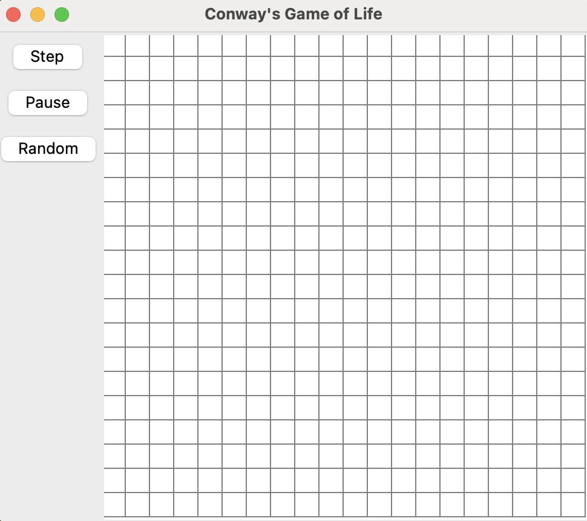

All life is extinct, all creatures are dead.

2.Death by oscillation

a.Simple case

The simulation starts to oscillate. It self repeats and any development is halted. Any progress is stopped and from a self-improvement point of view the model is dead.



b.Complex case

The model appears to be functional. But despite seemingly different stochastic activity being present on local levels, on global levels the simulation goes back to oscillating.

A one example of such a process would be a rock paper scissor simulation, with 3 colours who are the players, randomly placed on the simulation canvas.

They will keep going indefinitely and locally their motion might seem non repeating, whilst in reality no progress is being made.



Source ([Клеточные автоматы | Сделал игру жизнь в 3D](https://www.youtube.com/watch?v=FiO6jkNkrb4))

Another more complicated example, can be seen below, (SOURCE : Simulife Hub Clan Wars part 5 determination)

[Artificial Life. The battle of clans. Part 5. Predetermination](https://www.youtube.com/watch?v=6M4EgoHh608&t=6s)



These show that even in advanced and professional simulations researchers encounter a dead end and halt development (not immediately, more complex models tend to live longer, but when we aim for infinite development any X constant at which development halts is not-sufficient for our intents and purposes).

My hypothesis as per why it happens as I said previously lies in the fact that despite creating an advanced model all it’s capabilities just start looking for the most optimal solution to the environment, without trying to self develop since there is no feedback for the environment and creatures can not influence the environment in a duly fashion. In our project our focus would be the environment.

C.Project’s technical characteristics

For the core concepts, please refer to. Project announcement materials.  
<https://docs.google.com/document/d/1AGawXoOHsaq75R4sTslOV-R2H8ajvLNdmd5_aYAmu2Q/edit?usp=sharing>

In this section we would be building on the foundation we layed describing the concepts in bigger depth and the practical implementations. Here is the high level architecture of the project.

1.Creature architecture

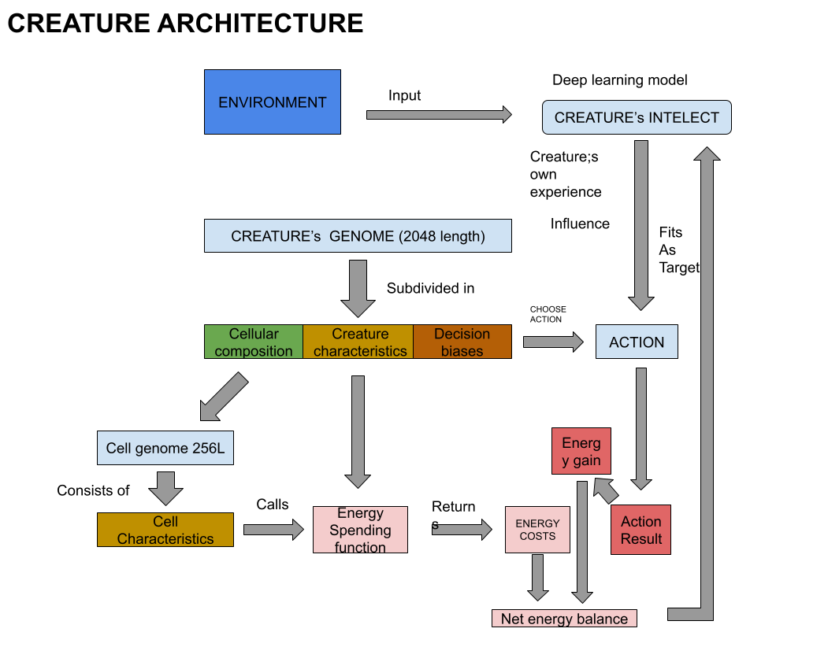

2.Creature and environment interaction architecture

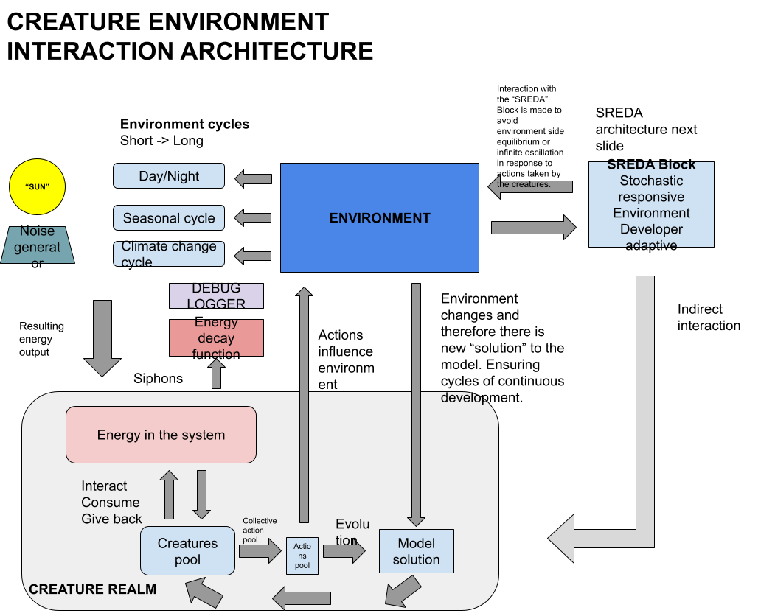4

43.SREDA block architecture

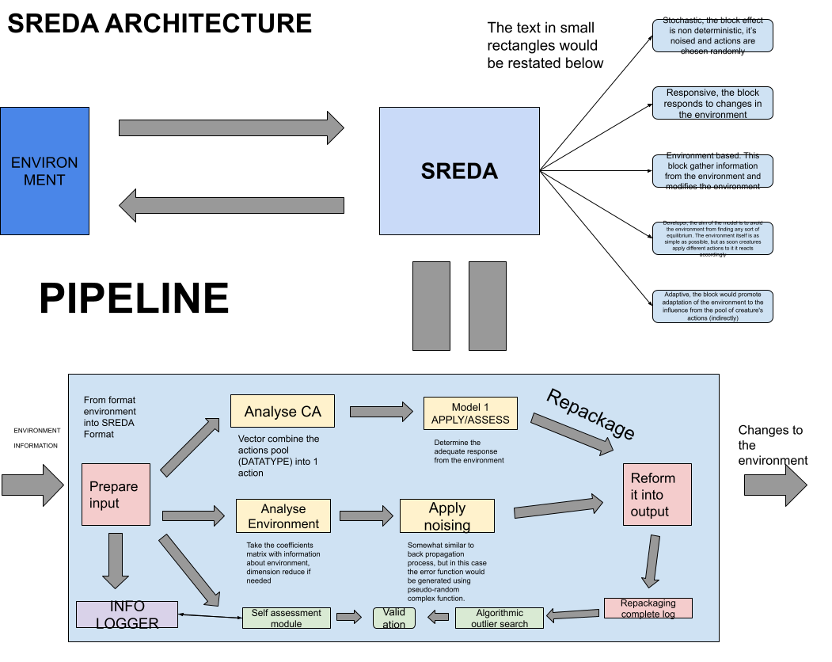

Clarifications.

The aim of the block is to avoid the environment/creature interaction from getting into any sort of constant equilibrium. The environment itself is as simple as possible (at the start), but as soon as creatures apply different actions to it it reacts accordingly and develops together with them.

Since the environment (like you will see in the next schema) is a “Super-Creature” and needs its own schema and architecture to clarify its structure and serve as a paradigm in future development.

If we look at alpha-zero, one of the most advanced chess engines, there are 2 AIs playing with each other, in order to reach top levels.

My system is significantly different, due to the nature of a study that we are conducting, but what matters is the approach.

In my simulation the creatures are the actors and all the creatures combine into a pool of creatures creating a “Giga-actor” and to interact with it there is a self-developing environment acting as a counter “Giga actor”.

Anyway it’s architecture is below

4.Enviroment architecture

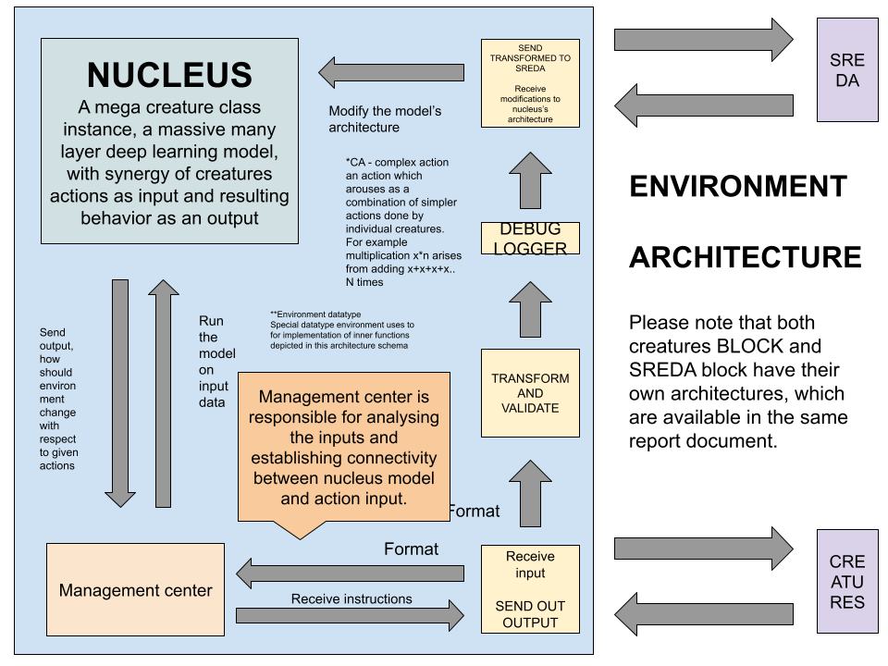

*(Colour of cells is defined by clustering algorithm, which judging by the characteristics finds the optimal colouring distribution)

D.Work completed

1)Interface

I have started with a basic CGL (Conway’s game of like interface) which was shown above during demonstration of developmental trends among the cellular automatons. This interface would serve as a basic template for the visualisator, for now.



Here is the project of the interface, of how it would look in it’s planned form.

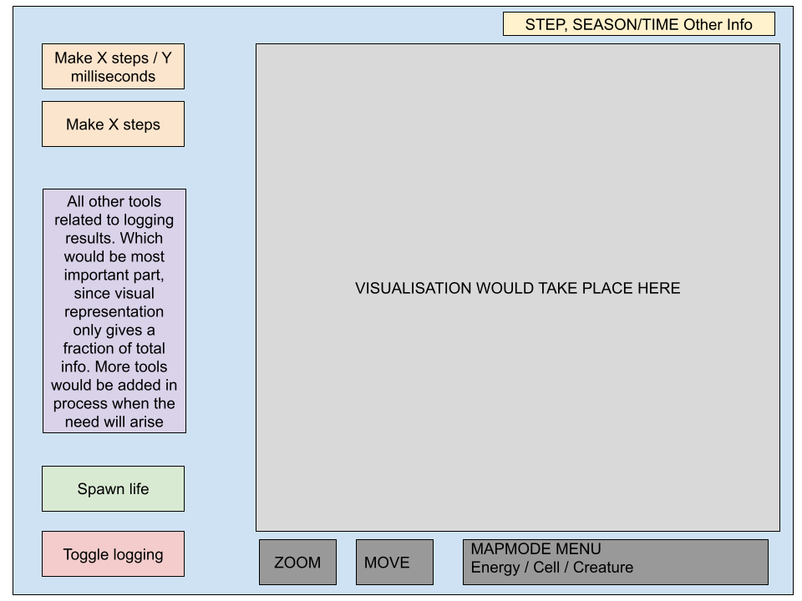

2)Energy distribution

I have completed the environment structure. And starting working on implementing different classes which we would need for the model. Below is the text-based presentation for the energy distribution algorithm (1000 steps). It is not connected to the visualisator yet, but has such a capability.

<https://drive.google.com/file/d/1H7CG5PhuiDAihxmearZAOc4Fl_kddYXJ/view?usp=sharing>

TERMINAL LOG

The simulation features day/night cycles and seasons, both with customizable length. Also it features completed implementation of the energetical decay over the course of time so that the tiles would not accumulate infinite energy.

3)Classes and structure

I have completed the structural part of the project, implementing the relations between classes, inheritances and dependencies. Also created a root folder structure.

E.Conclusions and future development.

During this week I have completed the theoretical vision of the project, as well as started working on some practical aspects of it. During week 2, I will begin more in depth work on the prototype, which, as I anticipated previously, I am planning to deliver by November 15th 2024.

5th November 2024 Appendix

Indeed, I already have an idea for the architecture. I am currently working on the prototype, currently it is not ready, but I am planning to deliver it by November 15th as promised.

When it comes to the practical implementation for the creature intellect a deep learning model would be used. As input there would be the creature's surroundings; amount of energy on tiles around it, different creatures' behaviours. As an output there will be action taken, or more precisely an action propensity bias, since the most important part of the decision making process would be handled by the corresponding part of the genome.

85% Decided by genome 15% By creature itself

(These values would be configurable in settings config and can be manipulated and studies)

The genome dominance in the current configuration is due to the fact that the deep learning model needs to go though many cycles of backpropagation to actually do something meaningful and in my idea, it would only play a minor part. It would act more as a noising than coherent mind capable of taking it's own decisions. At least at the early stages of the project. As the simulation gets older the creature's mind will (and will be given such capacity) to have greater influence on the creature's decision-making process. My hope is that by the end of the simulation creatures' minds would be able to overtake not only matter, but it's own deep encoded instincts (genome) and turn it to it's own advantage. Yet for obvious reasons, we will not directly incentive this action, since want the experiment to be clean and all the results to come out as a result of a simulation, not as a result of prior exterminator biases.

Hopefully I have managed to explain my vision, it might seem a bit bare bones/incomprehensive, but I hope that when I would finish the prototype it will clarify everything in a better way. Plus, in the process of development some technical formalities might change slightly.

https://plato.stanford.edu/entries/cellular-automata/